**INTRODUCTION**

* 1. **PROJECT TITLE**

Your Virtual Kitchen Assistant

**1.2 TEAM MEMBERS**

**NAME:** THASNIM BANU. I

**EMAIL ID:** [thasnimbanu03@gmail.com](mailto:thasnimbanu03@gmail.com)

**NAME:** SHAESTAH FARHEEN. M

**EMAIL ID:** [farheenshaestah@gmail.com](mailto:farheenshaestah@gmail.com)

**NAME:** HEPSIBA. R

**EMAIL ID:** [hepsiba12.007@gmail.com](mailto:hepsiba12.007@gmail.com)

**NAME:** VIJAYALAKSHMI. K

**EMAIL ID:** vijayalakshmik365@gamil.com

**NAME:** PRIYA. R

**EMAIL ID:** priyadhamodaran1410@gmail.com

**PROJECT OVERVIEW**

**2.1 PURPOSE**

Your Virtual Kitchen Assistant is a React-based application designed to help users manage recipes, plan meals, and track ingredients efficiently. The platform provides personalized recommendations based on dietary preferences and available ingredients.

**2.2 FEATURES**

* User authentication and profile management
* Recipe search and filtering by ingredients
* Meal planning and grocery list creation
* Ingredient inventory tracking
* AI-powered recipe suggestions
* Interactive cooking mode with step-by-step guidance

**ARCHITECTURE**

**3.1 COMPONENT STRUCTURE**

* **App.js**: Root component handling global state and routing.
* **Navbar.js**: Navigation bar for page transitions.
* **Home.js**: Displays featured recipes and user dashboard.
* **RecipeList.js**: Lists recipes with search and filter options.
* **RecipeDetail.js**: Shows recipe instructions and ingredients.
* **MealPlanner.js**: Allows users to create meal plans.
* **Inventory.js**: Manages ingredient tracking.

**3.2 STATE MANAGEMENT**

* **Redux Toolkit** is used for global state management.
* Local state is handled using React's useState and useReducer hooks.

**3.3 ROUTING**

* **React Router v6** is used for client-side routing.
* Routes:
  + /: Home
  + /recipes: Recipe list
  + /recipes/:id: Recipe details
  + /meal-planner: Meal planning
  + /inventory: Ingredient tracking
  + /login: Authentication

**SETUP INTRUCTIONS**

**4.1 PREREQUISITES**

* Node.js (v16+)
* npm or yarn
* React.js
* Redux Toolkit

**4.2 INSTALLATION**

1. **Clone the repository:**

git clone https

1. **Install dependencies:**

npm install

1. **Start the application:**

npm start

**FOLDER STRUCTURE**

/your-virtual-kitchen-assistant

│── /src

│ │── /components

│ │ ├── Navbar.js

│ │ ├── RecipeCard.js

│ │── /pages

│ │ ├── Home.js

│ │ ├── RecipeList.js

│ │── /redux

│ │ ├── store.js

│ │── /assets

│── package.json

│── README.md

**RUNNING THE APPLICATION**

**6.1 COMMANDS**

* **Start development server**: npm start
* **Build for production**: npm run build
* **Run tests**: npm test

**COMPONENT DOCUMENTATION**

**7.1 KEY COMPONENTS**

* **Navbar.js**: Handles navigation.
* **RecipeList.js**: Displays a list of recipes.
* **RecipeDetail.js**: Provides recipe instructions.

**7.2 REUSABLE COMPONENTS**

* **Button.js**: Customizable button component.
* **Card.js**: Used to display recipes in grid view

**SCREENSHOT**

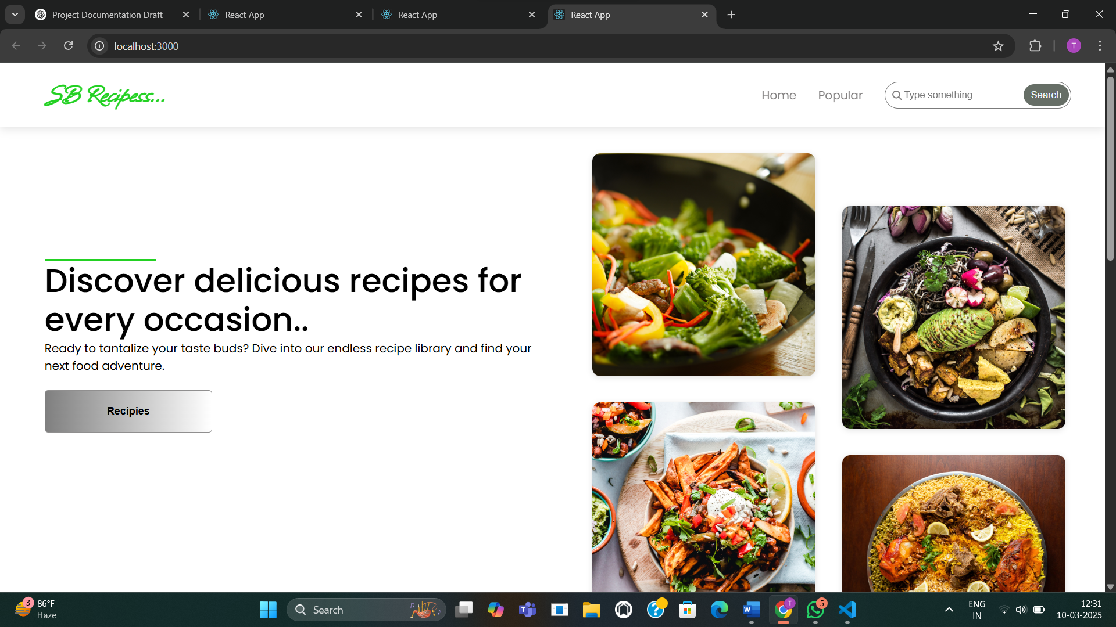

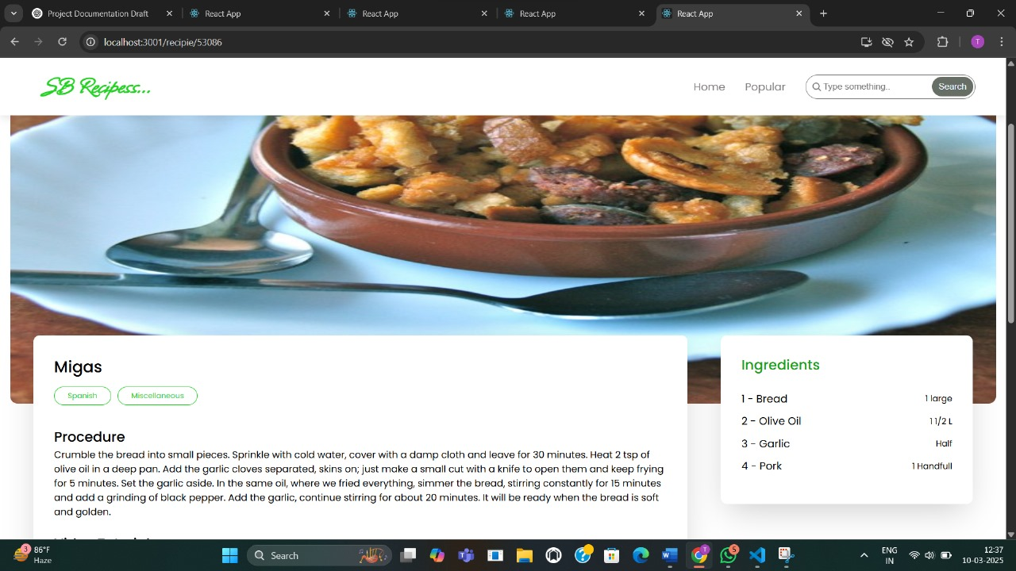

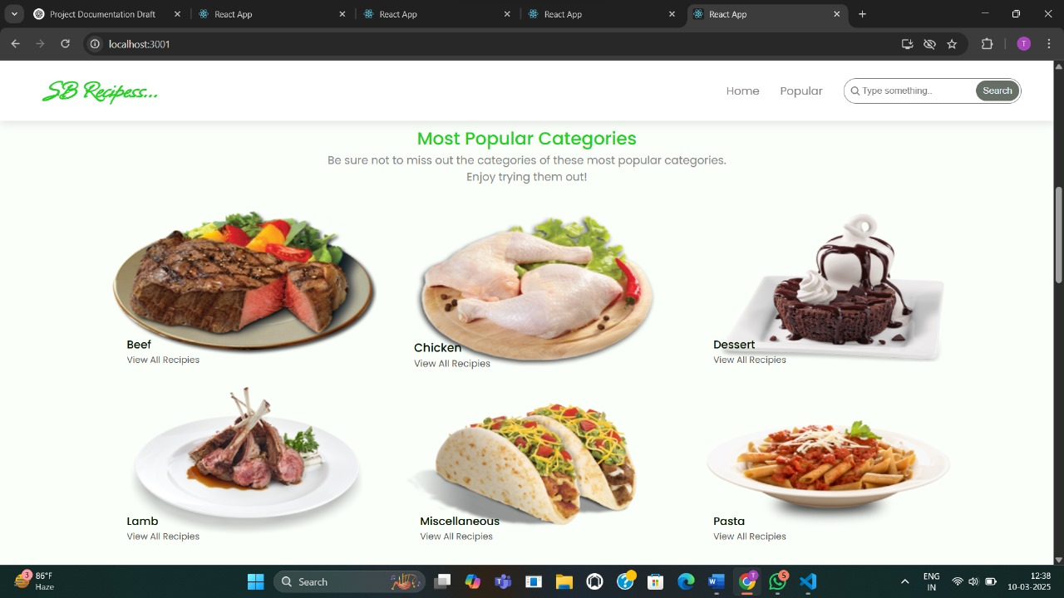

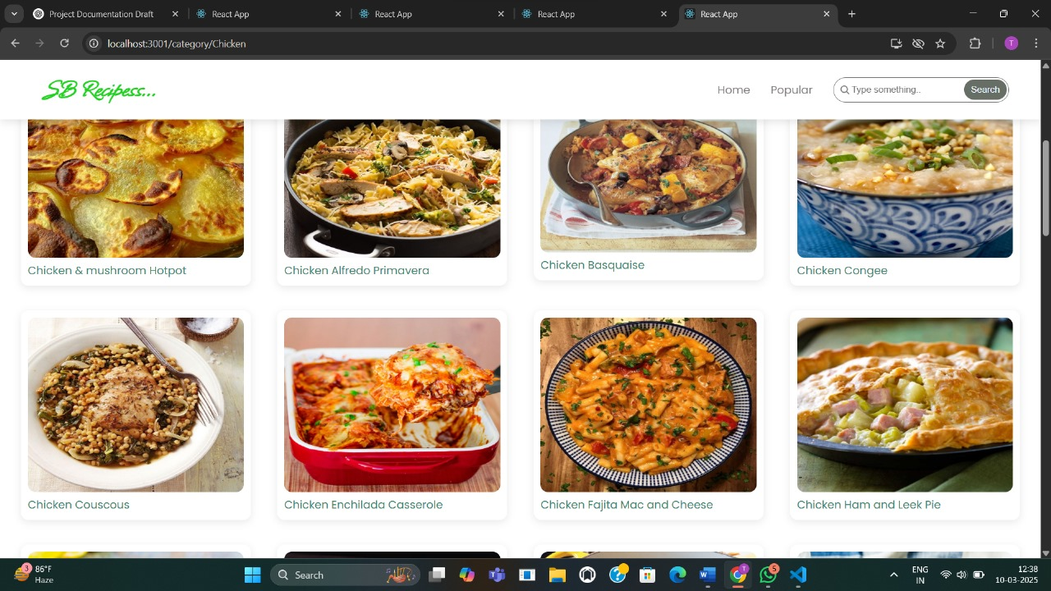

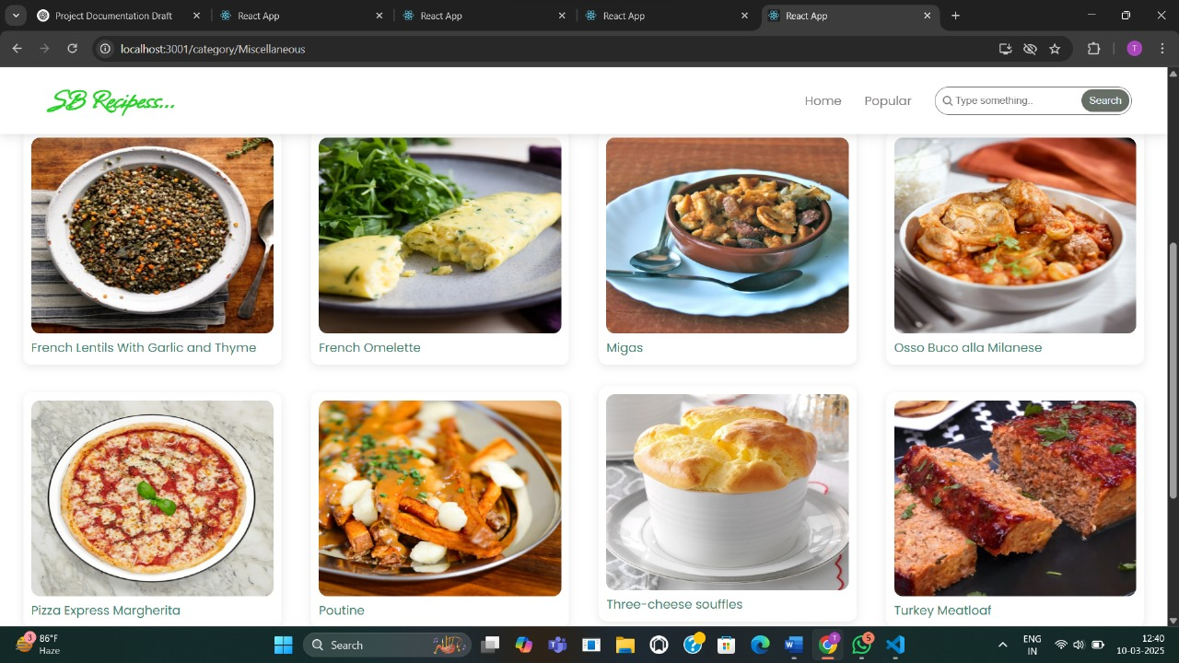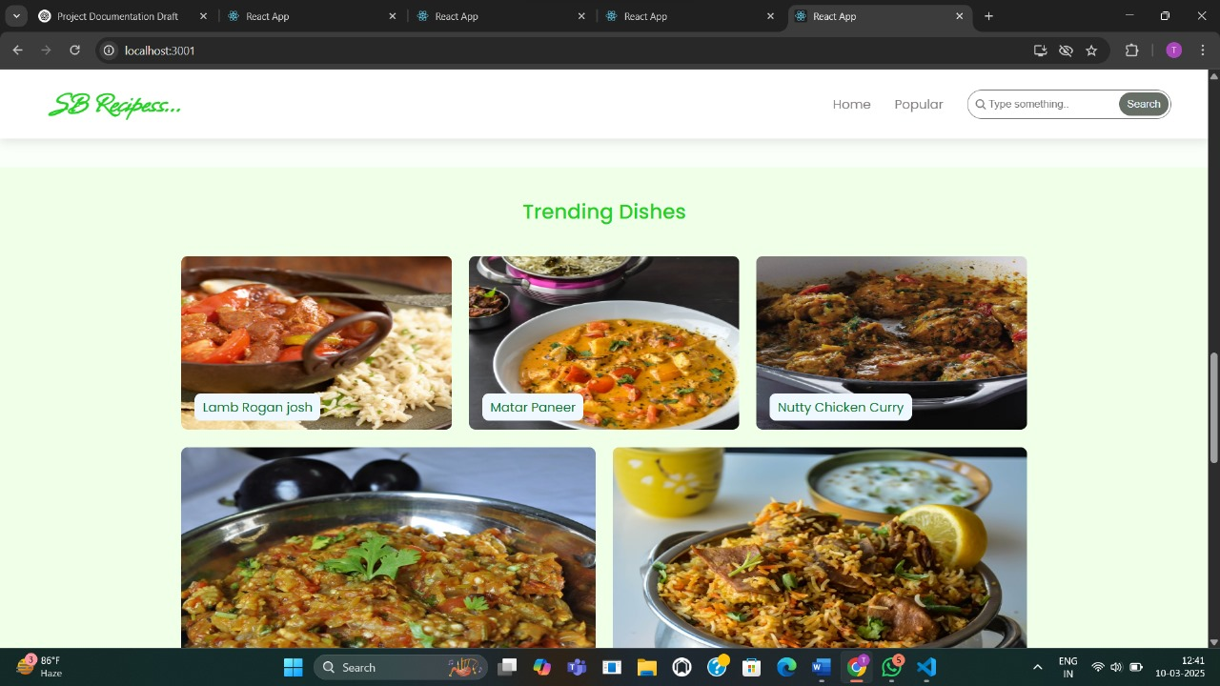

**TESTING**

**9.1 TESTING STRATEGY**

* **Unit Tests**: Jest and React Testing Library.
* **Integration Tests**: Cypress for end-to-end testing.
* **Code Coverage**: Istanbul for code coverage analysis.

**FUTURE ENHANCEMENT**

* AI-powered meal suggestions based on user history
* Voice-activated cooking instructions
* Dark mode and customizable themes
* Mobile application integration